Report On Bus Reservation System

Prepared By

Anitha Jinkala

26-03- 2022

Table of Contents:

1. Abstract
2. Introduction
3. Problem Specification

3.1 Problem definition

3.2 Existing System

3.3 Proposed System

4. System Design

5. System Output

6. Module Description

1.Abstact

Travelling is a large growing business across all countries. The Bus Reservation System deals with maintenance of records of each passenger who had reserved a seat for journey. It also includes the maintenance of information like schedule and details of each bus.

Through Bus Reservation System, maintain the seat availability for customers, price of per seat, bill generation and other things.

2.Introduction

The focus of this project is to computerize travelling company to manage data. Through this system it maintain the database of passengers and it keeps the records of all bills and also giving to ensure 100% successful implementation of the computerized Bus Reservation System.

This reservation system has three modules, they are

* First module retrieves data from tables required for enquire.
* Second module inserts values into the tables on reservation.
* Third module deletes values from the table on cancellation of tickets.

3.Problem Specification

In Bus Reservation System, there is no single system which automates all the process. In order to build the system, all the processes in the business should be studied, System study helps us under the problem and needs of the application.

System study aims at establishing requests for the system to be acquired, development and installed. It involves studying and analyzing the ways of an organization currently processing the data to produce information. In system analysis, prevailing situation of problem is carefully examined by breaking them into sub problems. Problematic areas are identified and information is collected.

Existing System:-

* Existing System is totally on book and thus a great amount of manual work has to be done. The amount of manual work increases exponentially with increase in bus services.
* Needs a lot of working staff and extra attention on all the records.
* In existing system, there are various problems like keeping records of items, seats available, price of per/seat and fixing bill generation on each seat.
* Major problem was lack of security.
* Finding out details regarding any information is very difficult, as the user has to go through all the books manually.

Proposed System:-

The system is very simple in design and to implement. The system requires very low system resources and the system will work in almost all configurations. It has got following features,

* Ensure data accuracy.
* Any person across the world, having internet can access this service.
* Availability seats can be enquired very easily.
* Passengers can also cancel their tickets easily.
* Minimum time needed for the various processing.
* Better service
* This would help the corporation prepare and organize its schedules more efficiently on the basis of traffic demand.

4.System Design

List of Entities:

1. **Bus Install**
2. **Reserve**
3. **Show**
4. **Buses Available**
5. **Exit**

List of Attributes:

Bus Install:

* Driver Name
* Bus ID
* Departure Time
* Arrival Time

Reserve Information:

* + - Bus Number
    - Passenger Name
    - Seat No

Show Information:

* Bus Number

5.System Output

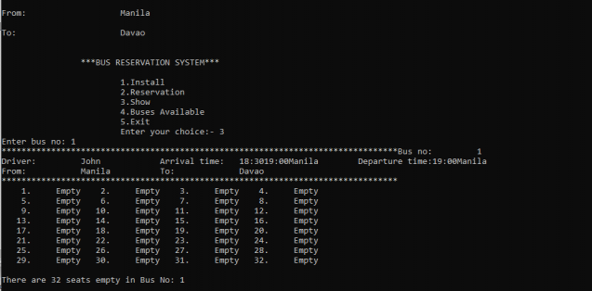

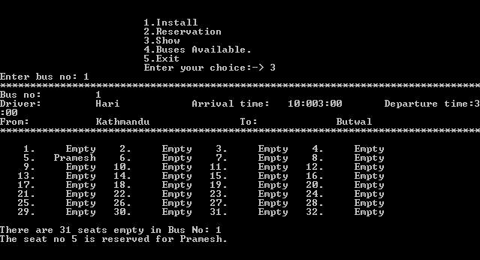

6.Module Description

Bus Module:

The main purpose of this module is provide all the functionality related to bus. It tracks all the information of the bus. We have developed all type of CRUD(Create, Read, Update and Delete) operations of the bus.

* Admin can add new bus records.
* Admin can see the list of bus details.
* Only admin can edit and update the record of the bus.
* Admin will be able to delete the records of the bus.
* All bus forms are validated on client side using JavaScript.

Bus Coach Module:

The main purpose for developing this module is to manage the bus coach data wise. So, all bus coach will be marked by admin or customer will be able to see bus coach report. Admin can see the list of all bus coach report.

* Admin can mark the news bus coach.
* Admin can edit/delete the news bus coach.
* Admin can see the list of all news bus coach.

Bus Schedule Module:

The main objective for developing this module is to manage the bus schedule data wise. So, all bus schedule will be managed by admin. Admin can see the list of all the bus Schedules and filter it according to the customer.

* Admin can manage the bus schedule.
* Admin can edit/delete the bus schedule.
* Admin can see the list of all bus schedule.
* Customer can see the bus schedule.

Bus Route Module:

The main aim for developing this module is to manage the bus route. Admin will manage all bus routes and customer will be able to see the bus route.

* Admin can manage the bus route.
* Admin can edit/delete the bus route.
* Admin can see the list of all bus route.
* Customer can see the bus route.